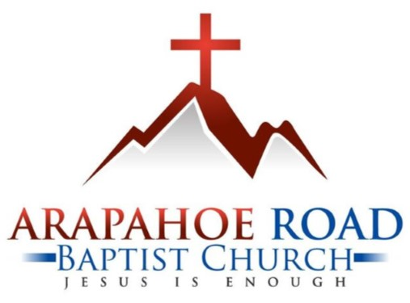

Open Position: Worship Le Arapahoe Road Baptist Church
780 East Arapahoe Road
Centennial CO 80122
303.794.3033
arbc.net

Open Position Worship Leader, Part Time
Arapahoe Road Baptist Church is a Bible-centered, evangelical Baptist Church located in Centennial, Colorado. We are looking for a Worship Leader to lead the congregation in the worship of our Lord and Savior Jesus Christ. Our worship service is a blended style using both traditional hymns and more contemporary worship songs.

Principal Function
Lead worship gatherings on Sunday mornings as directed by the Lead Pastor.

Duties and Responsibilities
- Actively and enthusiastically lead worshippers in the worship gathering on Sunday mornings in a way that enhances connection with our Savior, Jesus Christ, and encourages non-believers who may attend.
- Meet regularly with the Lead Pastor for accountability, strategy, and planning.
- Actively involve and engage all members and non-members who participate in the music ministry.
- Perform other related duties as designated by the Lead Pastor.

Qualifications
- Be a professing Christian.
- Positive attitude and good work ethic, in order to work in a professional environment that operates on a team concept.
- Ability to work the required days/hours and complete the demands of the job in a timely manner.
- Ability to sing and encourage others to sing along as well.
- Comfortable with leading worship using a microphone in front of an audience.

Application Process
Please email resume including at least two references to: carla_parmenter@arbc.net with subject line: Worship Leader Search

ARBC reserves the right to alter the position at any time.

