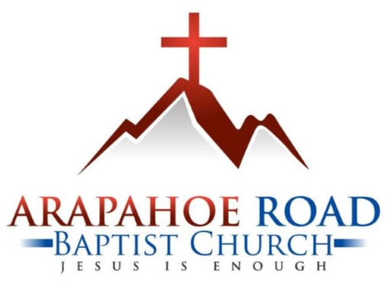

Open Position: Worship Le Arapahoe Road Baptist Church

780 East Arapahoe Road

Centennial CO 80122

303.794.3033

arbc.net

Open Position Administrative Assistant, Part Time

Would you like to be a part of a church whose mission is to connect all people to the truth and hope in Jesus? Are you looking for a place to serve Jesus by helping to welcome others with a smile and a readiness to help? Are you wanting to work in a place where you can grow in your relationship with Christ as well as develop skills to serve others along the way? ?  
  
Arapahoe Road Baptist Church (ARBC), located in south suburban Denver, has a position open for a part-time Administrative Assistant. ARBC, founded in 1960, is a well-established Church having a 135 active-member congregation who serve Jesus with love and enthusiasm. ARBC is a member of the Southern Baptist Convention (SBC), the Colorado Baptist Convention, and the Mile High Baptist Association. The part-time Administrative Assistant reports to Carla Parmenter, Office Manager.

Duties and Responsibilities

* Handles office duties on Wednesday and Thursday each week (and occasionally other days as needed). Duties include mail incoming and outgoing, answering the telephone, greeting guests, taking and relaying messages. Church access is remotely controlled from inside, with a security system in place.
* Attends the Wednesday weekly staff meeting contributing information, typing the minutes and updating the action plans.
* Coordinates with church volunteers who set up special events and promotions in the foyer, door hangers, etc.
* Gathers information one week ahead for the next week’s bulletin from the Music Team, Pastor, Deacons, and any Teams having announcements or events; also including items such as special offerings.
* Compiles the weekly church bulletin and publishes it by approximately noon on Thursday. Distributes bulletin by copying for Sunday and generates church-wide email. Also uploads onto website.
* Utilizes attendance records to determine quorum needed for next monthly Members Meeting.
* Prints and places Sunday School attendance sheets in classrooms weekly.
* Updates Worship and Sunday School attendance weekly in the database.
* Compiles attendance data and statistics for the Pastor’s monthly report to the church.
* Compiles and submits the Annual Church Profile to the SBC that includes ministries and leadership. Submits updates on the leadership profile.
* Updates Events held at ARBC on Nextdoor, the website, and Facebook Events.
* Creates and Schedules posts to ARBC Social Media (Facebook, Instagram, YouTube) 6 days per week.
* Creates graphics as needed for upcoming events or sermon series.
* Posts Sunday Sermon video on YouTube.
* Posts Sunday Sermon audio to Spotify.
* Occasionally assists in ordering supplies.
* Attend professional development activities as directed by the Pastor such as the Ministry Assistants of Colorado (MAC) conference that occurs each September.
* This position provides an opportunity for growth in cross-training in other positions in the office.

Qualifications

Professing Christian per John 3:16. Competent computer skills in Microsoft Office & Publisher, but training is available. Training will be given by ARBC to cover gaps in other skills. Embrace ARBC’s mission, vision, strategy, and values. Pass a background check. Legally able to work in the US. The position generally requires two days per week in the ARBC office, Wednesday, and Thursdays. Compensation based on qualifications and experience.

Application Process

Please send a resume, 2 references, and a cover letter that includes a paragraph discussing how the Administrative Assistant can contribute to ARBC’s mission of “*Connecting all people to the truth and hope in Jesus!*”.

Please mail documents to: or Email as a pdf attachment to:

Arapahoe Road Baptist Church carla_parmenter@arbc.net

(address above) Subject line: Administrative Assistant

ARBC reserves the right to alter the position at any time.