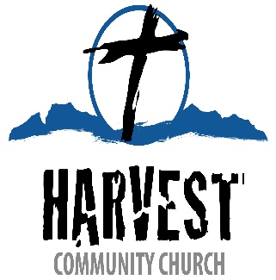

Harvest Community Church, located in Olathe, Colorado, is prayerfully seeking a Co-vocational Pastor. Olathe is a small town in western Colorado, known for its sweet corn and scenic views of the Uncompahgre Plateau. Harvest Community Church is looking for someone who has a deep love for people and souls. Someone who will lead and teach prayerfully and compassionately and strive to meet the spiritual needs of our people, community and surrounding area. We are a small, Bible believing Southern Baptist church. Our Pastor shall provide sound Biblical leadership and subscribe to the Baptist Faith and Message 2000.

Job Description:

* Maintain a vital and growing relationship with the Lord Jesus Christ
* Prepare, lead by example and proclaim the Word of God
* Participate in weekly scheduled church activities
* Work with the church leaders and ministry teams to carry out the mission and purpose of the church
* Moderate and lead church meetings
* Equip the congregation for ministry and evangelism
* Attend to the congregation’s pastoral needs including visitation, prayer, counseling.
* Perform Baptisms of new believers, perform weddings and funerals when available.

Qualifications:

* Believes that the Bible is the Holy Word of God
* Has a sure sense of God’s calling in his life to serve in Pastoral Ministry
* Has a sure sense that he serves under the guidance of the Holy Spirit
* Must meet the Biblical Qualifications for a Pastor (1Timothy 3:1-7, Titus 1:5-9, 1Peter 5:1-4)
* Born Again and has a clear personal testimony of his conversion commitment to Christ
* A man who can rightly divide the Word of God
* Personally affirms the SBC Baptist Faith and Message
* Capable of Expository Preaching

Send resumes to [HarvestOlathe@outlook.com](mailto:HarvestOlathe@outlook.com)

With your resume please send a link to previous sermons and your response to the following:

**Why do you believe that you are a good fit to serve as the Pastor for Harvest Community Church?**

**Describe your experiences in ministry and how that experience qualifies you to serve as the Pastor of Harvest Community Church?**

**In just a few sentences please give a summary of your theology and how it lines up with the doctrine of the Baptist Faith and Message 2000.**